CORPORATE FINANCE PREREQUISITES
FORMULA SHEET
Metric / concept | Formula
Current ratio | Current Assets / Current Liabilities
Quick ratio | (Cash + Receivables) / Current Liabilities
Debt / Equity | Financial Debt / Equity
Interest coverage | EBIT / Interest Expense
Net margin | Net Income / Revenue
ROA | Net Income / Average Total Assets
ROE | Net Income / Average Equity
Asset turnover | Revenue / Average Total Assets
Future Value | FV = PV × (1 + r)^n
Present Value | PV = FV / (1 + r)^n
Bond value | PV of coupons + PV of face value
Gordon Growth | P0 = D1 / (r − g)
NPV | PV of future project cash flows − initial investment
IRR | Discount rate that makes NPV = 0

EXERCISE 4 · What is the promise worth?
Part A - Future Value
- You invest EUR 1,000 today at 8% per year for three years. What is the Future Value at the end of Year 3?

Part B Present Value and decision
An investment promises the following cash flows:
Year | Cash flow (EUR)
1 | 450
2 | 550
3 | 650
2. Using a required return of 8%, calculate the Present Value of each cash flow and the total Present Value.
3. The seller asks EUR 1,400 today. Would you invest? Explain.
4. The investment becomes riskier and your required return rises to 12%. Recalculate the total Present Value.
5. Explain in one sentence why the Present Value changed although the promised cash flows did not.

EXERCISE 5
Two investment opportunities require the same initial investment. Both generate a total cash inflow of EUR 120,000 over three years.
However, the timing of cash flows is different.
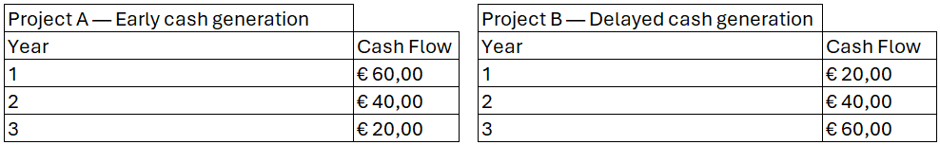
Required return: 10%
1. Calculate the Present Value of Project A.
2. Calculate the Present Value of Project B.
3. Both projects generate exactly EUR 120,000 in total cash flows. Why are their values different?
4. Which project would you prefer as a CFO if both require the same initial investment? Explain.
5. What general principle about cash flow timing can you derive from this example?

